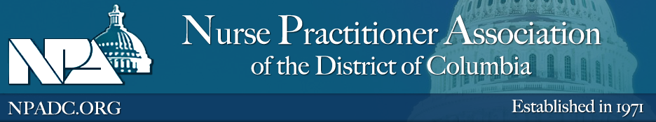
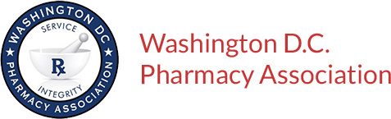
NPADC and WDCPhA 2018 Conference
Safe and Effective Prescribing: Strengthening Pharmacists and Nurse Practitioners to Improve Patient Outcomes
SATURDAY, NOVEMBER 17, 2018
Time: 8:30 am – 1:30 pm
Audience: The program is open for pharmacists and pharmacy technicians.
Location: Howard University Hospital Towers Building
- Sibley Memorial Hospital
- 5255 Loughboro Rd, NW, Washington, DC 20016
Registration Fee: Free
Activity Type: Knowledge
Sponsor: Nurse Practitioner Association of DC & The Washington DC Pharmacy Association
EVENT TIME | TITLE | Faculty | Learning Express Access Code*
09:00 – 10:00 am | Distinguishing Evidence from Marketing to Ensure Appropriate Prescribing. | Adrienne Fugh-Berman, MD  Miranda G. Law, PharmD., BCPS,
10:00 – 11:00 am | It is Time to Talk!! Innovative Strategies that can be Utilized to Address Medication Adherence in Community Practice/Real World/the District of Columbia | Jacqueise Unonu, PharmD, AAHIV  Jess Calohan, DNP, PMHNP-BC
11:00 am - 12:00 pm | The Dangers of Polypharmacy: Raising Awareness While Striving to Improve the Quality of Care Among Patients in the District of Columbia | Christopher Keeys, PharmD  Laurie Wilson, MSN, APRN, AGPCNP-BC
12:15 - 01:15 pm | Safety in Drug and Drug-Nutrient Interaction | Lawrence Momodou, PharmD, MBA, CPH  Victoria Wood, MPH, CNS
01:15 - 02:15 pm | Collaborative Practices Agreements (CPA) are Coming: An Exciting Opportunity to Improve Healthcare Access and Delivery in the District of Columbia | Carlisha Gentles, PharmD, BCPS, CDE,  Paolo Acevedo, PharmD.

*Learning Express is the LMS used by Howard University College of Pharmacy Office of Continuing Professional Education to provide CE Certificate and linked to the CPE Monitor (https://hurxce.learningexpressce.com/index.cfm).

The Howard University College of Pharmacy Office of Continuing Professional Education is accredited by the Accreditation Council for Pharmacy Education as a provider of continuing. To access your CE certificate, please login to: (https://hurxce.learningexpressce.com/index.cfm) until Jan 12. 2019.

